Test Case: tc002_SPX_Dev5_Crear_Requisicion_Spot_Tipo_Cobro_Project
Step 1 - Enter username and password and click to button Enter: Credentials Entered
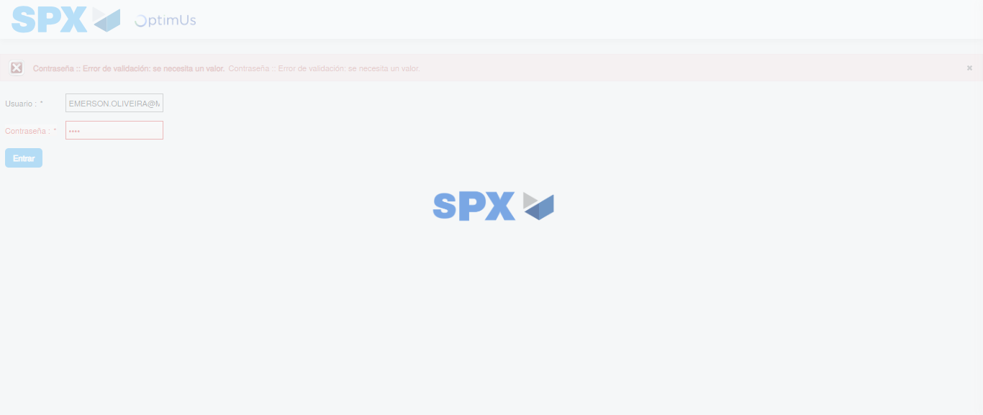Image file-name: QC_Testing-tc002_SPX_Dev5_Crear_Requisicion_Spot_Tipo_Cobro_Project-1785974624285

Step 2 - Select to UEN and Access to Spot Buy Requisitions : UEN Correctly selected and Correct access
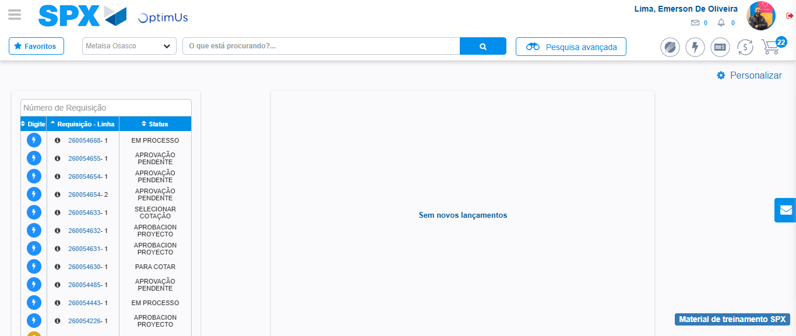Image file-name: QC_Testing-tc002_SPX_Dev5_Crear_Requisicion_Spot_Tipo_Cobro_Project-1785974649558

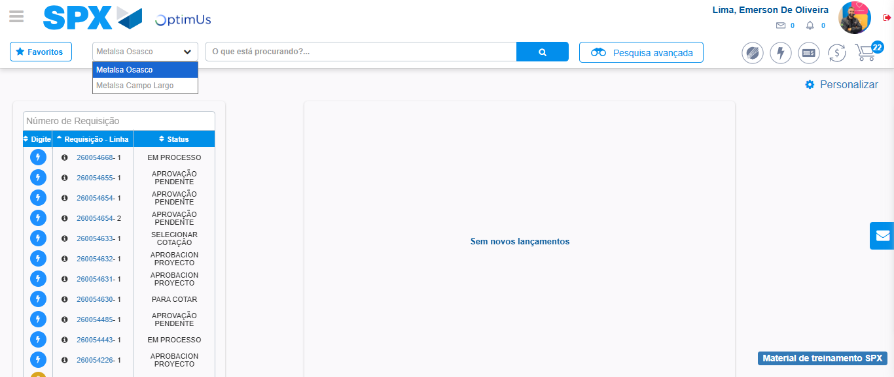Image file-name: QC_Testing-tc002_SPX_Dev5_Crear_Requisicion_Spot_Tipo_Cobro_Project-1785974652005

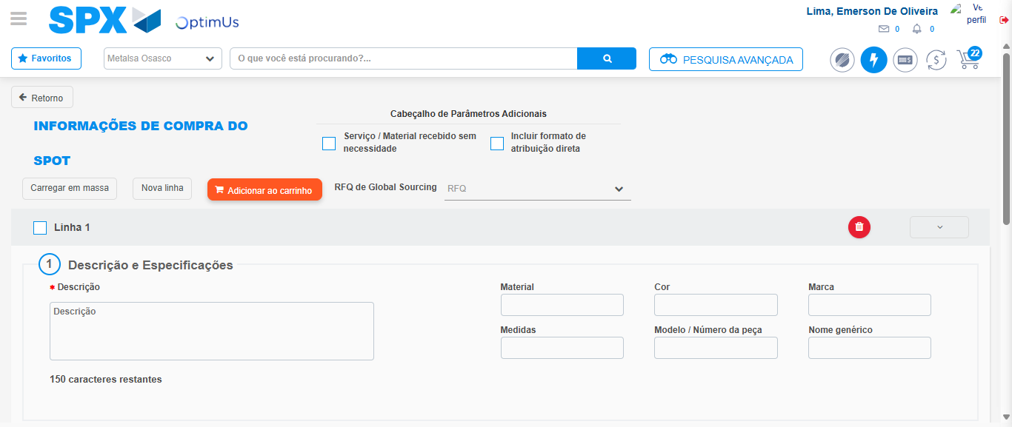Image file-name: QC_Testing-tc002_SPX_Dev5_Crear_Requisicion_Spot_Tipo_Cobro_Project-1785974660128

Step 3 - Data Capture Spot Buy Requisition: Data captured correctly
Image file-name: QC_Testing-tc002_SPX_Dev5_Crear_Requisicion_Spot_Tipo_Cobro_Project-1785974660375

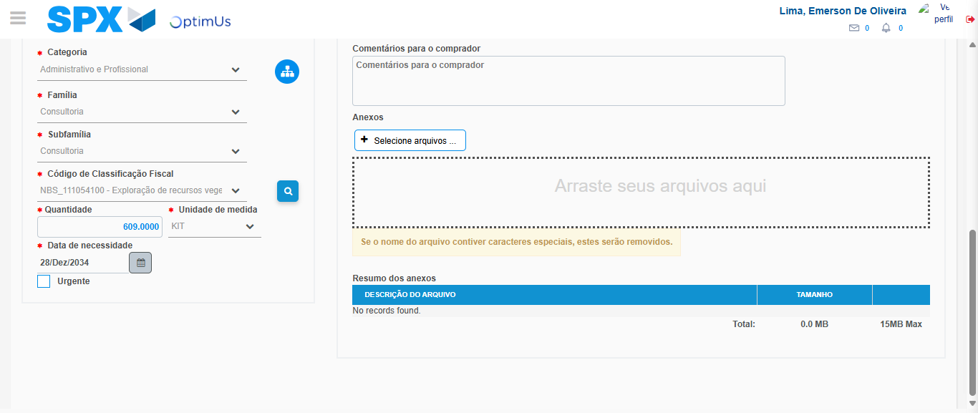Image file-name: QC_Testing-tc002_SPX_Dev5_Crear_Requisicion_Spot_Tipo_Cobro_Project-1785974676634

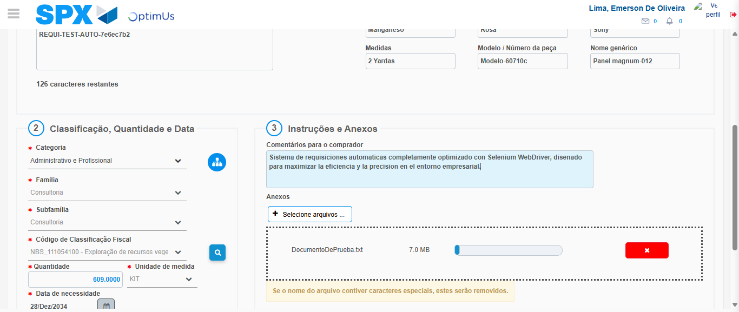Image file-name: QC_Testing-tc002_SPX_Dev5_Crear_Requisicion_Spot_Tipo_Cobro_Project-1785974677366

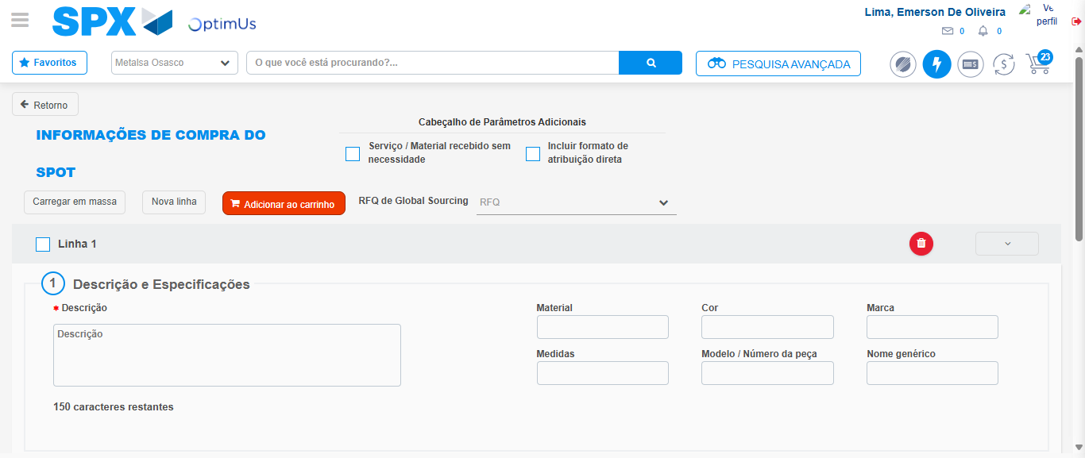Image file-name: QC_Testing-tc002_SPX_Dev5_Crear_Requisicion_Spot_Tipo_Cobro_Project-1785974684810

Step 7 - Return to Main Page SPX : Return to Main Page SPX
Image file-name: QC_Testing-tc002_SPX_Dev5_Crear_Requisicion_Spot_Tipo_Cobro_Project-1785974649558

Image file-name: QC_Testing-tc002_SPX_Dev5_Crear_Requisicion_Spot_Tipo_Cobro_Project-1785974652005

Image file-name: QC_Testing-tc002_SPX_Dev5_Crear_Requisicion_Spot_Tipo_Cobro_Project-1785974660128

Image file-name: QC_Testing-tc002_SPX_Dev5_Crear_Requisicion_Spot_Tipo_Cobro_Project-1785974687094

Image file-name: QC_Testing-tc002_SPX_Dev5_Crear_Requisicion_Spot_Tipo_Cobro_Project-1785974687266

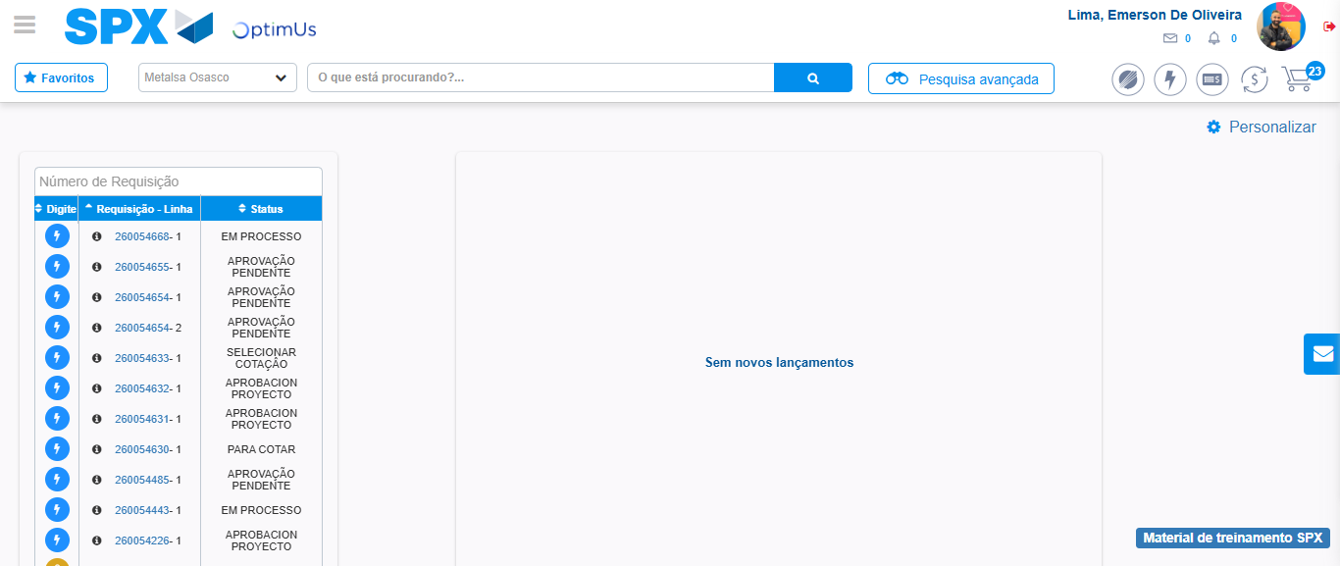Image file-name: QC_Testing-tc002_SPX_Dev5_Crear_Requisicion_Spot_Tipo_Cobro_Project-1785974708321

Step 8 - Log Out : Log Out SPX
Image file-name: QC_Testing-tc002_SPX_Dev5_Crear_Requisicion_Spot_Tipo_Cobro_Project-1785974708531

